**Columns**

The columns CSS shorthand property sets the number of columns to use when drawing an element's contents, as well as those columns' widths.

It is used to set both **column-count** and **column-width** properties at the same time. Both of these properties are used to control how many columns will appear. The **column-count** property is used to set the number of columns, whereas the **column-width** property specifies the width of the columns.

Together using **column-count** and **column-width** properties creates a multi-column layout that breaks automatically into a single column at narrow browser widths without using the media queries. It is not always helpful to use both of them because it can restrict the responsiveness and flexibility of the layout.

If the column-count and width don't fit in the element's width, then the browser reduces the column count automatically to fit the specified column widths.

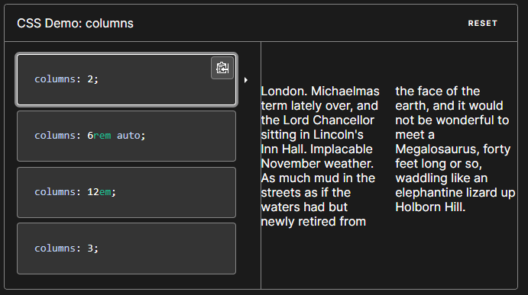

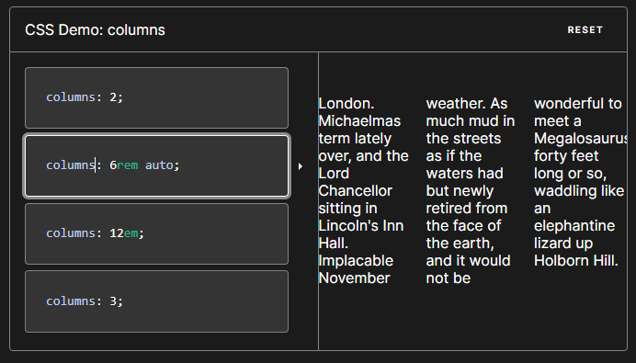

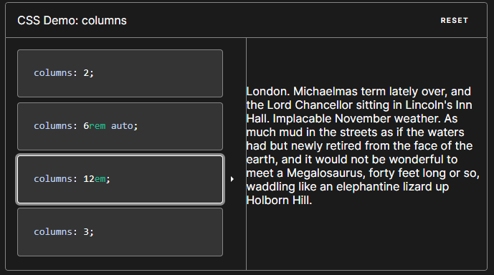

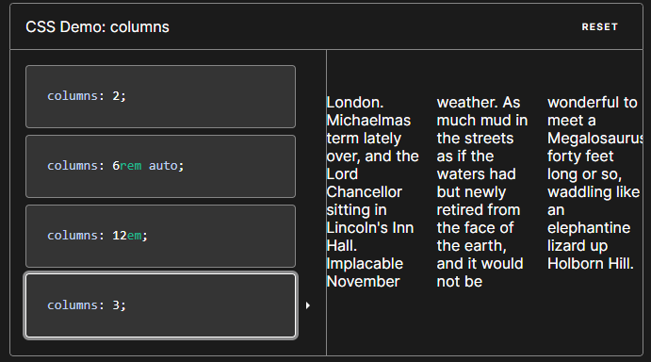

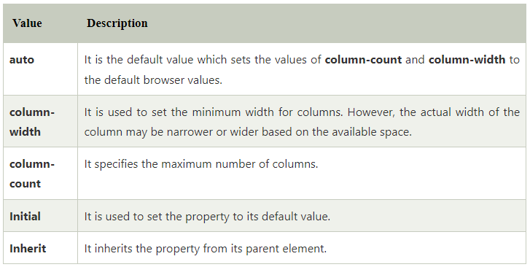

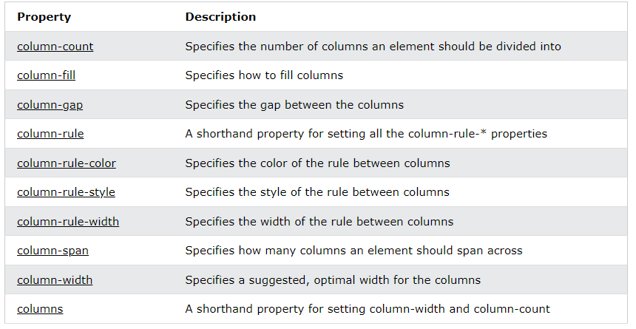

Example

<!DOCTYPE html>

<html>

<head>

<style>

.div1 {

columns: 100px 4;

border: solid 2px black;

font-size: 20px;

}

.div2 {

columns: 100px 6;

border: solid 2px black;

font-size: 20px;

}

</style>

</head>

<body>

<h1> The columns Property </h1>

<h4> The columns property is a shorthand property for column-width and column-count </h4>

<h3> Set the column-width to 100px, and column-count 4 </h3>

<div class="div1">

Hi, Welcome to the javaTpoint.com. This site is developed so that students may learn computer science related technologies easily. The javaTpoint.com is committed to providing easy and in-depth tutorials on various technologies. Here, you will find lots of tutorials that are easy to understand and learn.

No one is perfect in this world, and nothing is eternally best. But we can try to be better.

</div>

<h3> Set the column-width to 100px, and column-count to 6 </h3>

<div class="div2">

Hi, Welcome to the javaTpoint.com. This site is developed so that students may learn computer science related technologies easily. The javaTpoint.com is committed to providing easy and in-depth tutorials on various technologies. Here, you will find lots of tutorials that are easy to understand and learn.

No one is perfect in this world, and nothing is eternally best. But we can try to be better.

</div>

</body>

</html>

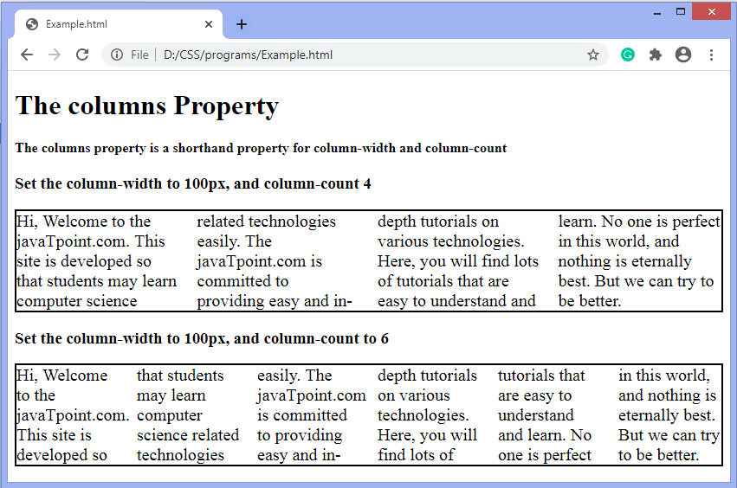

**Using Columns with elements**

1. break-inside
2. break-before
3. white-space - nowarp